**Intent Fitness Functionality**

**App Store**

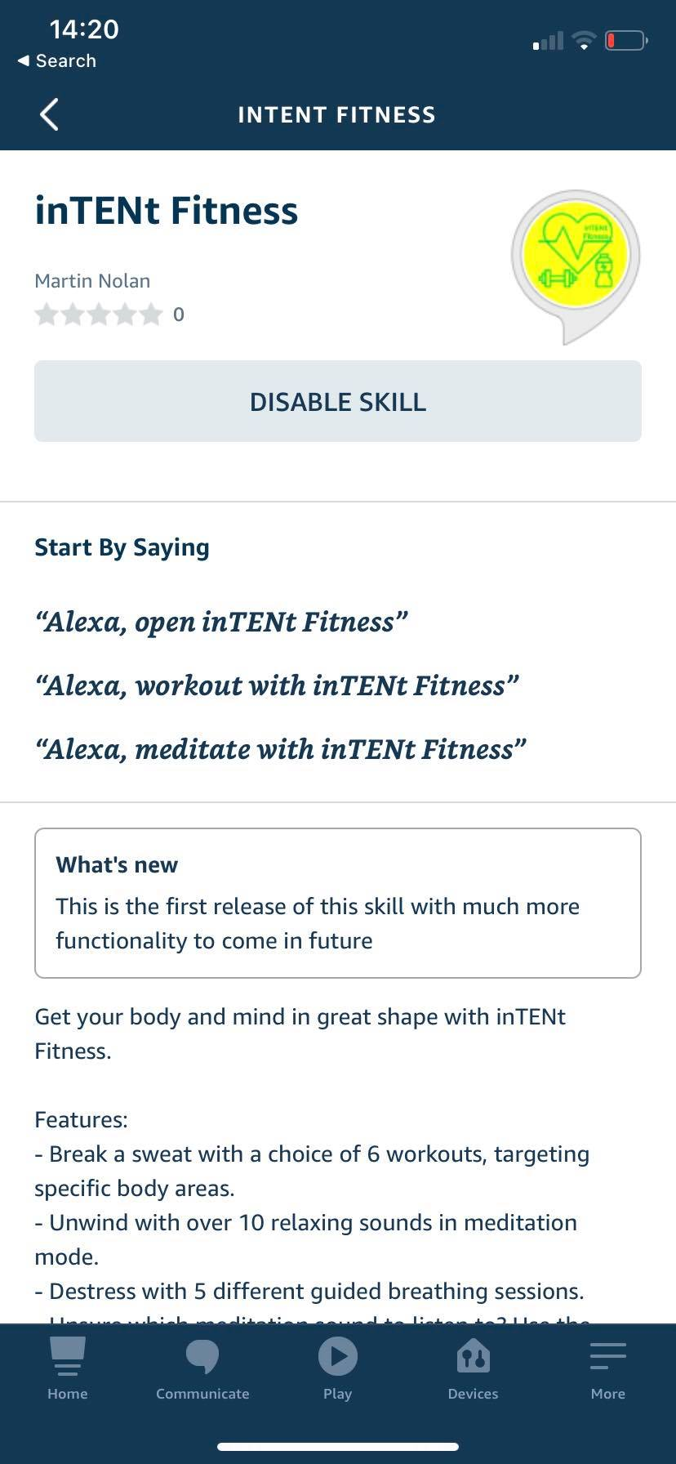 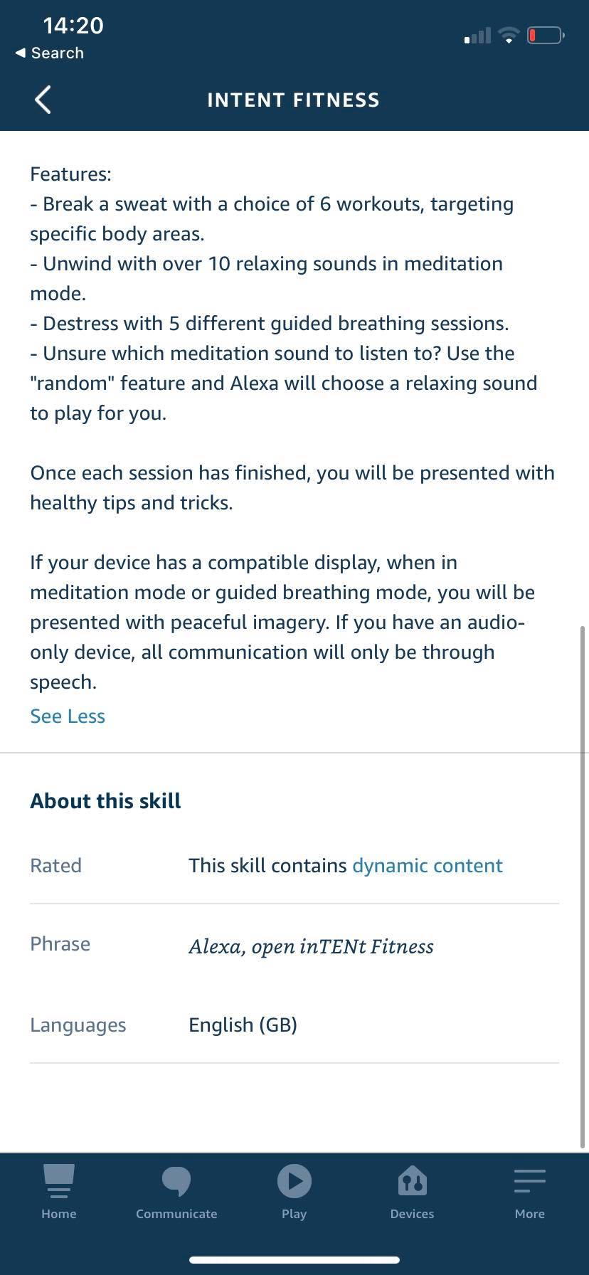

|  |  |  |
| --- | --- | --- |
| **Features Included** | **Features Removed** | **Screenshot** |
| Welcome user and get them to choose from 3 different mode. |  |  |
| In meditation mode, choose to listen to 12 different sounds. |  |  |
| Choose random feature for Alexa to pick a random relaxing sound for you. |  |  |
| If using a visual device, all sounds output album artwork and background images. |  |  |
| Give user healthy tips (choose from 25) and congratulate at end. | Previously, I wanted user to be able to turn this option on and off, but I chose to change this. |  |
| Choose from 5 different guided breathing sessions. |  |  |
| Complete 10-minute guided breathing session. |  |  |
| If you have a visual device, all sounds output album artwork and background images. |  |  |
| Give user healthy tips (choose from 25) and congratulate at end. | Previously, I wanted user to be able to turn this option on and off, but I chose to change this. |  |
| Choose from 6 different workouts. |  |  |
| Target upper, lower, or full body workout. |  |  |
| Choose an intensity level and complete a 10-minute workout. |  |  |
| If you have a visual device, all sounds output album artwork and background images. |  |  |
| Give user healthy tips (choose from 25) and congratulate at end. | Previously, I wanted user to be able to turn this option on and off, but I chose to change this. |  |
| Users can ask for help. |  |  |
| Users can ask what type of sounds they can listen to. |  |  |
| Users can ask Alexa to repeat what she just said. |  |  |
| When completing a workout, music will play at the time users are meant to workout. | Previously, I wanted users to link to their Spotify to listen to music, but this was not feasible. I wanted the user to be able to turn off the background music in settings if desired. |  |
|  | As the user exits the application, they should be asked if they wish to set up daily reminders (at a specified time) to work out. This should be incorporated with Alexa routines. I decided against this as Amazon’s standards mean you must implement user permissions to get their time-zone etc, and this did not seem worth it to add one additional feature. |  |